LAB EXPERIMENT RECORD
Set 21: Energy Consumption Data

Department | AIML
Course Code / Course Name | DSA0601 / Data Handling and Visualization
Experiment | Data Visualization using R and Tableau
Name | G. GANGA CHANDRIKA
Register Number | 1925260144
Date | 15 October 2026
Day | Thursday

Aim
To import the Energy_Consumption_Data.csv dataset, analyse energy consumption patterns using a histogram, density plot, bubble scatter plot and bar chart in R, and to build an interactive dashboard with a line chart and heatmap in Tableau.
Dataset: Energy_Consumption_Data.csv
Sector | Region | Month | Temperature (°C) | Units_Consumed (kWh) | Cost (₹) | Renewable_Usage (%) | Peak_Hours
Residential | North | Jan | 15 | 320 | 2100 | 22 | 4
Commercial | South | Jan | 24 | 540 | 3600 | 18 | 6
Industrial | West | Feb | 20 | 880 | 5900 | 12 | 8
Residential | East | Feb | 18 | 350 | 2300 | 25 | 5
Commercial | North | Mar | 28 | 610 | 4100 | 20 | 7
Industrial | South | Mar | 30 | 920 | 6200 | 15 | 9

PROGRAM 1: Histogram and Density Plot of Units_Consumed
Import the dataset in R. Plot a histogram and a density plot for Units_Consumed and compare the consumption patterns.
# Import / create the dataset
energy <- data.frame(
Sector = c("Residential", "Commercial", "Industrial",
"Residential", "Commercial", "Industrial"),
Region = c("North", "South", "West", "East", "North", "South"),
Month = c("Jan", "Jan", "Feb", "Feb", "Mar", "Mar"),
Temperature = c(15, 24, 20, 18, 28, 30),
Units_Consumed = c(320, 540, 880, 350, 610, 920),
Cost = c(2100, 3600, 5900, 2300, 4100, 6200),
Renewable_Usage = c(22, 18, 12, 25, 20, 15),
Peak_Hours = c(4, 6, 8, 5, 7, 9)
)
# Display the dataset
print(energy)
library(ggplot2)
# Histogram
ggplot(energy, aes(x = Units_Consumed)) +
geom_histogram(binwidth = 150, fill = "skyblue",
color = "black", alpha = 0.7) +
labs(title = "Histogram of Energy Consumption",
x = "Units Consumed (kWh)",
y = "Frequency") +
theme_minimal()
# Density plot
ggplot(energy, aes(x = Units_Consumed)) +
geom_density(fill = "orange", alpha = 0.5) +
labs(title = "Density Plot of Energy Consumption",
x = "Units Consumed (kWh)",
y = "Density") +
theme_minimal()
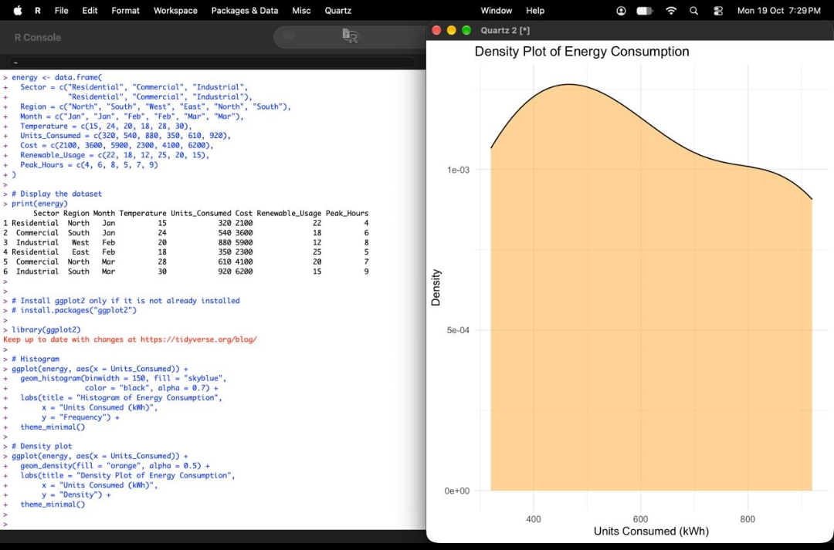
Output 1: Dataset and Density Plot of Energy Consumption
Observation: The density curve peaks at roughly 400–500 kWh, where the Residential (320, 350) and Commercial (540, 610) readings cluster, and shows a second, lower shoulder near 800–900 kWh, which is formed by the Industrial readings (880, 920). The histogram groups the same values into bins of width 150 kWh and shows the same pattern: most observations are in the lower-consumption range, with a smaller group at the high end. The distribution is therefore spread out and not symmetric, and the high-consumption group belongs to the Industrial sector.

PROGRAM 2: Scatter Plot of Temperature vs Units_Consumed
Create a scatter plot between Temperature and Units_Consumed. Represent Peak_Hours using bubble size and apply transparency.
library(ggplot2)
ggplot(energy, aes(x = Temperature,
y = Units_Consumed,
size = Peak_Hours,
color = Sector)) +
geom_point(alpha = 0.6) +
labs(title = "Temperature vs Energy Consumption",
x = "Temperature (°C)",
y = "Units Consumed (kWh)",
size = "Peak Hours",
color = "Sector") +
theme_minimal()
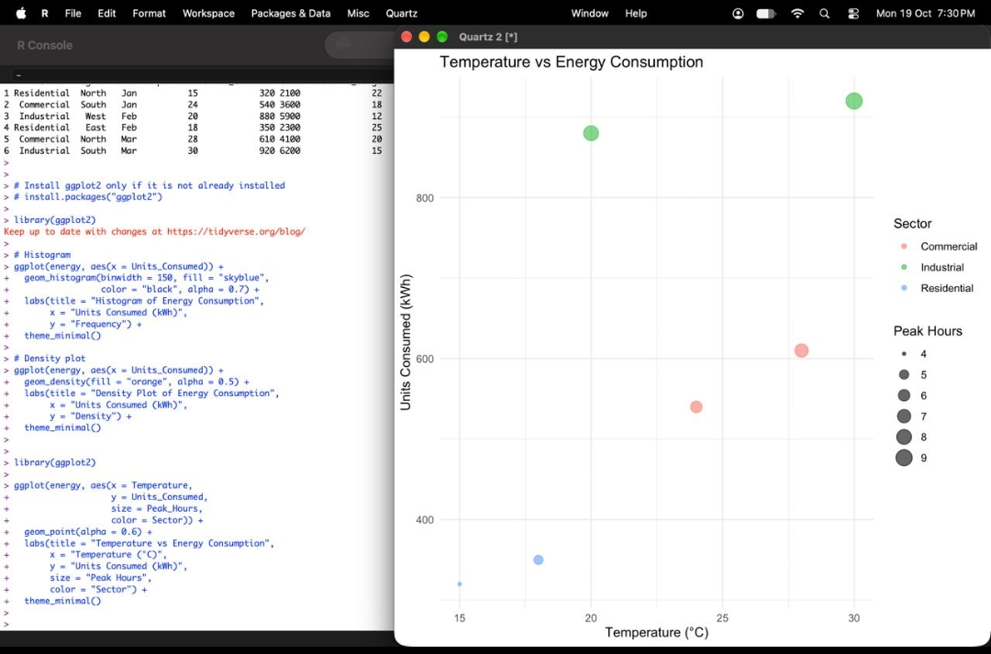
Output 2: Temperature vs Energy Consumption (Bubble Plot)
Insight: Units consumed generally rise with temperature: the lowest readings (320 and 350 kWh) occur at 15 °C and 18 °C, and the highest (920 kWh) occurs at 30 °C. Bubble size grows with Peak_Hours, so the largest bubbles (8 and 9 peak hours) are also the highest-consumption points. Colour shows that the Industrial points sit well above the others, so the sector affects consumption as much as temperature does. The alpha = 0.6 transparency keeps overlapping bubbles visible.

PROGRAM 3: Average Renewable_Usage by Sector
Calculate the average Renewable_Usage for each Sector, create a bar chart and interpret renewable energy adoption.
library(ggplot2)
# Calculate average renewable usage
avg_renewable <- aggregate(
Renewable_Usage ~ Sector,
data = energy,
FUN = mean
)
# Display the result
print(avg_renewable)
# Create bar chart
ggplot(avg_renewable,
aes(x = Sector, y = Renewable_Usage,
fill = Sector)) +
geom_col() +
geom_text(aes(label = paste0(
round(Renewable_Usage, 1), "%")),
vjust = -0.5) +
labs(title = "Average Renewable Energy Usage by Sector",
x = "Sector",
y = "Average Renewable Usage (%)") +
theme_minimal() +
theme(legend.position = "none") +
expand_limits(y = 30)
Sector | Average Renewable_Usage (%)
Commercial | 19.0
Industrial | 13.5
Residential | 23.5

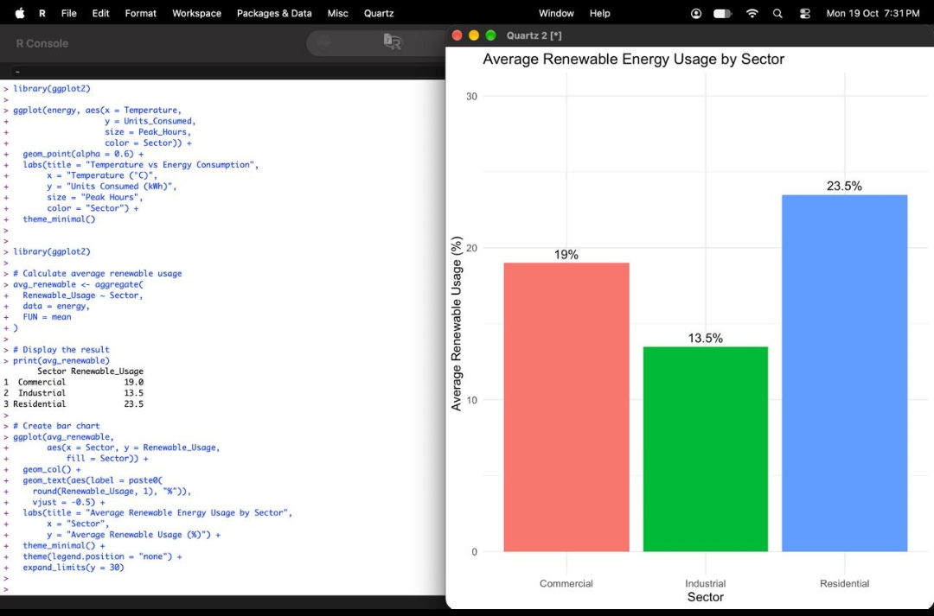
Output 3: Average Renewable Energy Usage by Sector
Interpretation: Residential has the highest average renewable share (23.5%), followed by Commercial (19.0%), while Industrial has the lowest (13.5%). Industrial is the largest consumer of electricity (880 and 920 kWh) yet relies least on renewable sources, so it offers the greatest potential for increasing renewable adoption, for example through rooftop solar or renewable power purchase agreements. Residential adoption is already the strongest and can be sustained with incentives.

PROGRAM 4: Interactive Energy Dashboard in Tableau
Import Energy_Consumption_Data.csv into Tableau. Create a line chart for monthly energy usage trends and a heatmap (Sector vs Region vs Units). Add filters for Month and Sector and design an interactive dashboard.
Steps followed in Tableau
1. Open Tableau and connect to Text file, then select Energy_Consumption_Data.csv.
2. Sheet 1 (Line chart): drag Month to Columns and Units_Consumed (SUM) to Rows, and set the mark type to Line with circles on the points.
3. Sheet 2 (Heatmap): drag Region to Columns, Sector to Rows and Units_Consumed to Color and Label, then set the mark type to Square.
4. Add Month and Sector to the Filters shelf of each sheet and choose Show Filter.
5. Create a new Dashboard, add the line chart and the heatmap, and apply the Month and Sector filters to both sheets (Apply to Worksheets > Selected Worksheets).
6. Name the dashboard "Energy Consumption Dashboard" and test the filters.

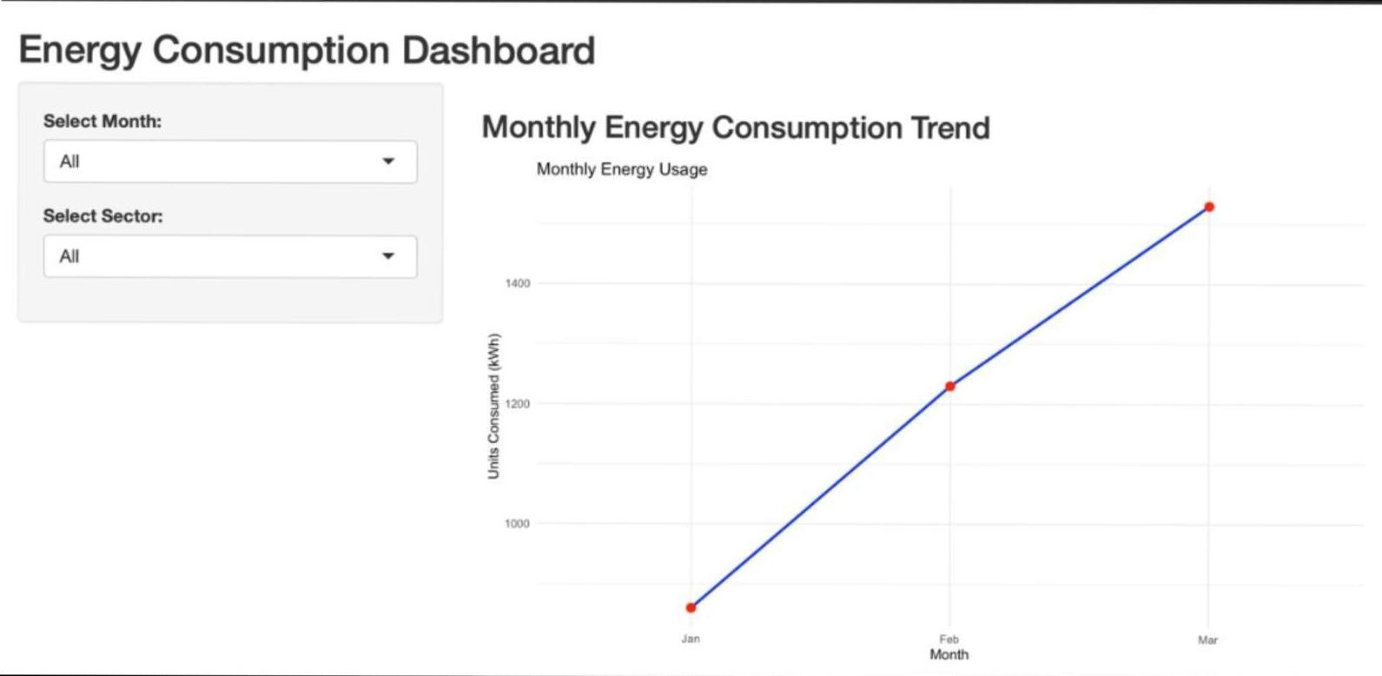
Output 4(a): Energy Consumption Dashboard with Monthly Trend Line Chart and Filters
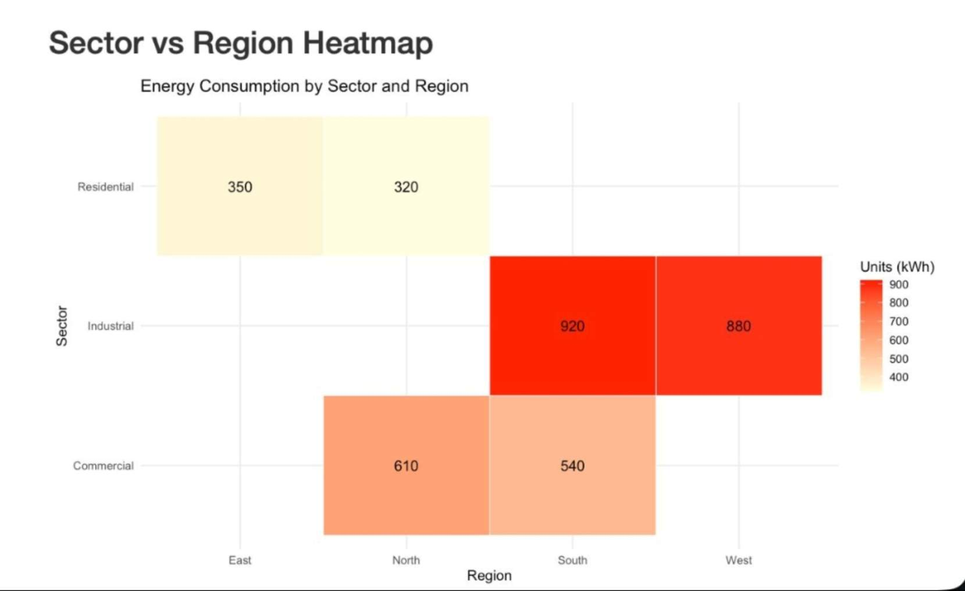
Output 4(b): Sector vs Region Heatmap of Units Consumed
Observation: Monthly energy use rises from 860 kWh in January to 1,230 kWh in February and 1,530 kWh in March. The heatmap shows the darkest cells for Industrial in South (920) and West (880), moderate shades for Commercial in North (610) and South (540), and the lightest cells for Residential in East (350) and North (320). The Month and Sector filters update the dashboard interactively.
Procedure
1. Create the energy data frame in R and display it with print().
2. Install and load the ggplot2 package.
3. Use geom_histogram() and geom_density() to plot the distribution of Units_Consumed.
4. Use geom_point() with size = Peak_Hours, color = Sector and alpha = 0.6 for the bubble scatter plot.
5. Use aggregate() to compute the mean Renewable_Usage per Sector and plot it with geom_col().
6. Import the CSV into Tableau, build the line chart and heatmap, add the Month and Sector filters, and combine them into a dashboard.
Result
The energy consumption data was successfully analysed in R using a histogram, density plot, bubble scatter plot and bar chart of average renewable usage, and an interactive Tableau dashboard with a monthly trend line chart, a Sector vs Region heatmap and Month and Sector filters was created.
Key Functions Used
Function / Feature | Purpose
data.frame() | Creates the energy dataset in R.
ggplot() | Initialises a plot and maps variables to aesthetics.
geom_histogram() | Plots the frequency distribution of Units_Consumed.
geom_density() | Plots the smoothed density of Units_Consumed.
geom_point() | Draws the scatter / bubble plot with transparency (alpha).
aggregate() | Calculates average Renewable_Usage for each Sector.
geom_col() / geom_text() | Draws the bar chart and adds value labels.
Tableau Filters / Dashboard | Provide Month and Sector filtering on the combined dashboard.

